Chemistry

Unit 4

Area of study 6 Test Answers:

Organic synthesis

Section 1: Multiple choice (12 marks)

Question 1

C Biodiesel contains methyl esters. A is an acid, B is the sodium salt of an acid and D is glycerol.

Question 2

A An ionic salt of a long-chain carboxylic acid

Soaps are formed from the base hydrolysis of fats. They have a charged carboxylate end and a non-polar hydrocarbon tail, which gives rise to the cleaning action of a soap.

Question 3

A Branching does not allow close approach of polymer chains. So branching causes chains to be further apart, leading to a lower density material. With chains further apart, the dispersion forces between them are weaker and so the melting temperature is lower.

Question 4

C HOOCCH2CH2COOH and HOCH2CH2OH

Esters are formed from the reaction between an acid and an alcohol. To form a polyester, the monomers need to be a diol and a dicarboxylic acid. Alternatively, a single molecule containing both an alcohol and an acid group can react to form a polymer.

Question 5

A Because these monomers have double bonds, they will undergo addition polymerisation. These monomers can join either =CH2=CHOH to CH2=CHOH or CH2=CHOH to CHOH=CH2. A combination of these two possibilities would result in the polymer drawn.

Question 6

C HOOCCH2CH2CH2COOH and HOCHBrCH2OH

End of section 1

Section 2: Short answer (13 marks)

\* Indicates 1 mark

Question 7

a

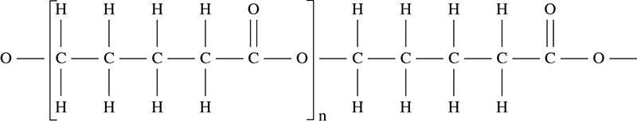

(2 marks)

b polyester or condensation polymer (1 mark)

c

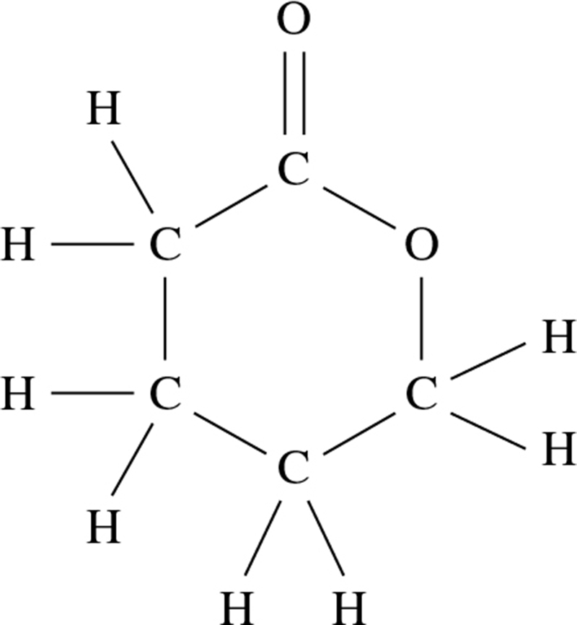

(1 mark)

Question 8 (6 marks)

a Both stearic acid and lauric acid contain long saturated, non-polar hydrocarbon chains, attached to the polar carboxylic acid functional group.

The polar carboxylic groups are able to form hydrogen bonds between molecules.\* However, the hydrocarbon chains are non-polar, and hence form dispersion forces between molecules.\*

As the strength of the dispersion forces increases with a greater number of electrons,\* the larger fatty acid, stearic acid, has a higher melting point than lauric acid.

b Both stearic acid and linoleic acid contain long saturated, non-polar hydrocarbon chains, attached to the polar carboxylic acid functional group.

The polar carboxylic groups are able to form hydrogen bonds between molecules.\*

Linoleic acid and stearic acid have similar molar masses, and therefore have the capacity to form similar strength dispersion forces between their non-polar hydrocarbon tails, as they have a similar number of electrons.\*

The presence of the double bonds in linoleic acid in the cis-form mean that the linoleic acid molecules are unable to pack together as closely in the solid form, compared to the linear stearic acid.\*

The greater distance between molecules reduces the strength of the intermolecular forces and results in a lower melting point.

Question 9 (3 marks)

Any three for 3 marks

• The lipase method is conducted at lower temperatures than the base-catalysed method.

• The lipase method is conducted at lower pressures than the base-catalysed method.

• Sodium hydroxide can only be used for one cycle of the production process, whereas lipase can be used many times.

• The yield of the base-catalysed method is higher than the lipase method.

• The lipase method has a slower rate of reaction than the base catalysed method.

End of section 2

Section 3: Extended answer (17 marks)

\* Indicates 1 mark

Question 10 (10 marks)

a i

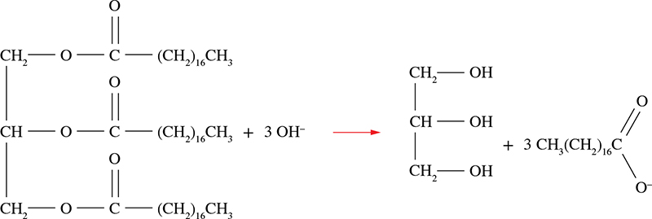

(3 marks)

ii

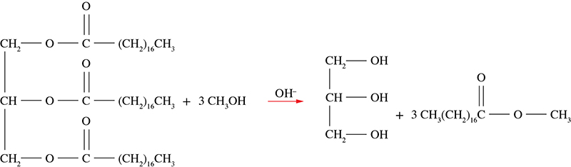

(3 marks)

b i They both have a negatively charged functional group that can form ion–dipole attractions with water.\*

And a long non-polar hydrocarbon tail that does not form favourable interactions with water, but is able to interact with non-polar grease, fats and oils.\*

ii Soaps form precipitates when used in hard water, as the calcium and magnesium salts of a soap anion are insoluble in water.\*

Detergents do not form insoluble salts with Ca2+ and Mg2+.\*

Question 11 (7 marks)

a condensation or polyamide\*

b hydrogen bonds\*

c

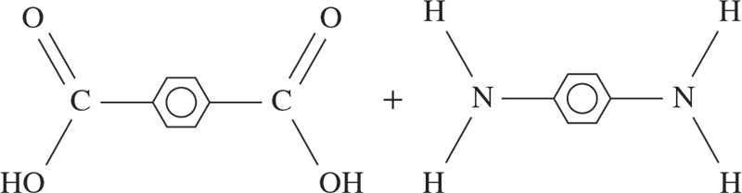

(2 marks)

d

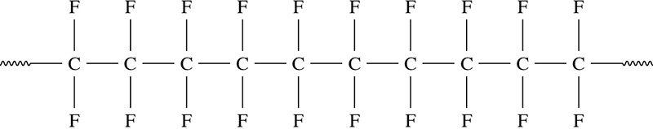

(2 marks)

e addition polymer\*

End of answers